

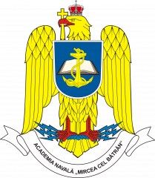
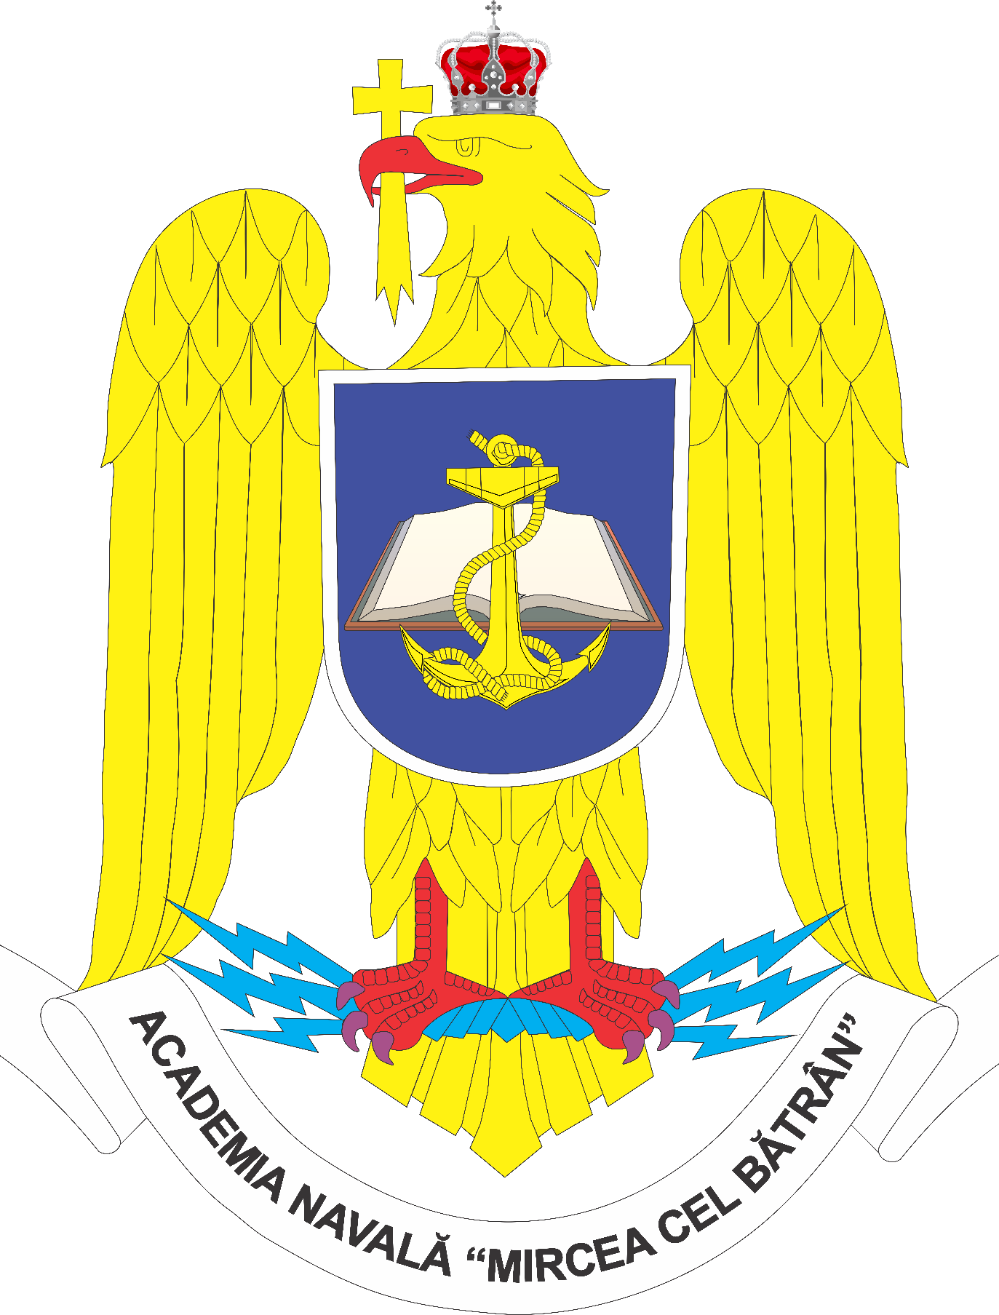

Romanian Naval Academy
”Mircea cel Bătrân”

Certificate

This is to certify that

Kacper TODA
passed the

” Key Terminology and Functional Concepts in Military English”
Blended intensive programme 2024-1-RO01-KA131-HED-000210551-4

Conducted during
Virtual component: 17th of November – 21st of November, 2025
Physical mobility: 10th - 14th of November, 2025
Constanța, ROMANIA

valid for 3 ECTS

ViceRector for International Programs of
Romanian Naval Academy

Col. Assoc. Prof. Catalin POPA, PhD

