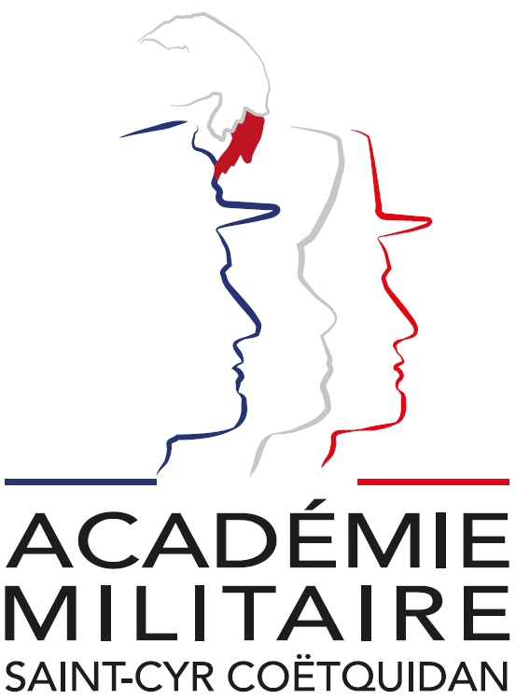

International Spring Semester
2027

War Studies

Institutional Data Sheet
Erasmus ID code | F GUER01
Erasmus+ Coordinator | Mr Emmanuel Berberian  E-mail: cyr.international@st-cyr.terre-net.defense.gouv.fr  Phone: +33 2 97 70 73 75
Dates | Arrival date: January 14-15, 2027 (Please respect these dates)  Start of the course: January 18, 2027  End of the course: June 04, 2027  Return day: June 07-08, 2027  Dates may be subject to change
Student Requirements | - B2 level in English  - Bachelor’s degree (or equivalent)
Documents required for the application | - Application form  - Medical certificate  - Reduced medical booklet  - ID or Passport scan  - 1 ID photo
Application deadline | All applications must be submitted by December 04th, 2026.
Meals & Accommodations | According to EMILYO-LoD 5 (framework), accommodation, meals, and other expenses in relation to the education are free of charge for members of European Union Basic Officer Education Institutions (http://www.emilyo.eu/node/982).
Remarks | All incoming cadets must reach Rennes by their own means. The cadets will be picked up at Rennes airport or train station by a shuttle/bus. Due to limited availability of vehicles, there will be only one pick-up per day; so be aware that you may have to wait a bit if you arrive early.

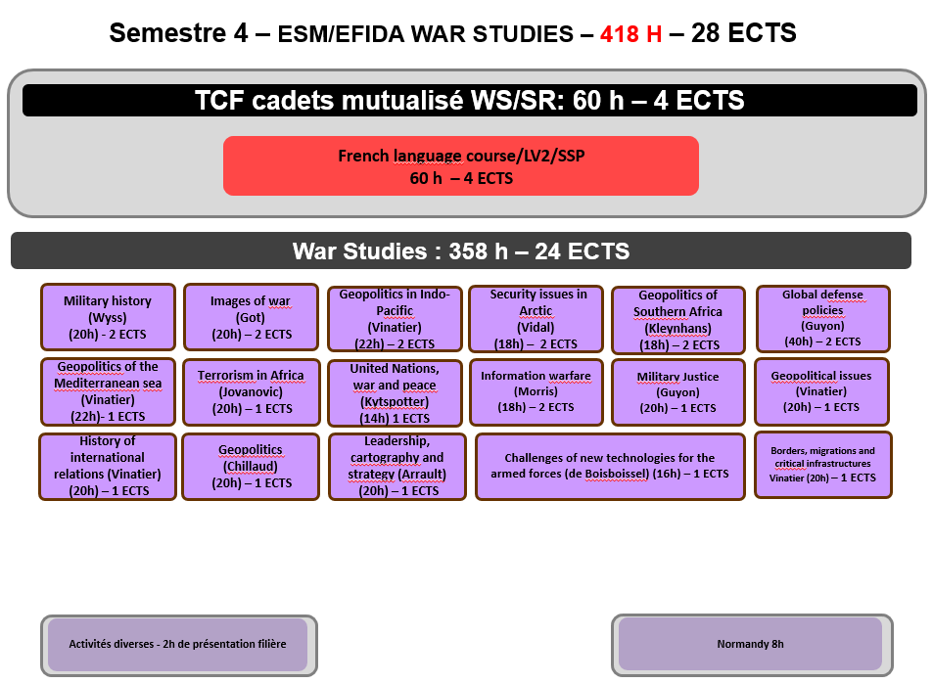

WAR STUDIES

Headed by M. Gwenaël GUYON, Assoc. Prof. in Law
gwenael.guyon@st-cyr.terre-net.defense.gouv.fr

Introduction:
War Studies is a multidisciplinary department that offers an analysis of war and defence issues from a social sciences perspective.
It draws on French and international lecturers and experts.

Course I
Course title | Common Module – French language
Course duration | 60 | ECTS Credits | 4
Course objectives  (target skills) | This module is shared with the International Spring Semester 2026 – War Studies and gives the cadets the opportunity to discover more about France and its culture.
Detailed course content | - French as a foreign language  - Sport activities  - Staff trip on the Normandy D-Day sites
Methods /Teaching resources | French language course
Assessment criteria | //
Professor’s name | AMSCC Professor

Course II
Course title | GEOPOLITICAL ISSUES
Course duration | 20 | ECTS Credits | 1
Course objectives  (target skills) | This module includes group research work. Divided into groups of different nationalities, cadets will prepare a presentation on a specific geopolitical issue.
Detailed course content | Presentation on a geopolitical issue
Methods /Teaching resources | Individual and collective research, group presentations
Assessment criteria | 1h oral examination before a jury
Professor’s name | Edgar Vinatier

Course III
Course title | GEOPOLITICS OF SOUTHERN AFRICA
Course duration | 18 | ECTS Credits | 2
Course objectives  (target skills) | This course will examine Geopolitics and insurrections in Southern Africa, stressing examples of South Africa, Namibia, Mozambique and Angola. Counter-insurrections, Military issues, Security issues and Piracy, among others, will be at the heart of this class.
Detailed course content | Through the history of southern Africa, and in particular the history of the wars since the Second World War (Mozambique, Angola, etc.), this course provides a geopolitical, strategic and political understanding of these conflicts.
Methods /Teaching resources | Teachings, group presentations
Assessment criteria | 2x1h exam
Professor’s name | Evert Klynhans

Course IV
Course title | GEOPOLITICS OF THE INDO-PACIFIC
Course duration | 22 | ECTS Credits | 2
Course objectives  (target skills) | The aim of the course is to have a study in depth of both concept and reality by focusing on main actors. The key issues will be regional order, strategy and vision, diplomacy, policies, cooperation and integration, military tensions, piracy, terrorism, energy resources, natural resources, major shipping routes, submarine cables, migration patterns and remittances.
Detailed course content | - US, China, India, Japan, Australia, France and the EU  - Regional organisations  - TransNational Companies  - NGOs and transnational organised crime
Methods /Teaching resources | The methodology is based on many case studies of subregions and strategic chokepoints: the Malacca Strait, the Taiwan Strait, the South China Sea, the East China Sea, the Indian Ocean, the horn of Africa and the Strait of Bab-el-Mandeb, the Strait of Hormuz, the Indian subcontinent, Australia, New Zealand and the Pacific islands.  Teamwork, cooperative spirit and team communication skills will be required.
Assessment criteria | 2h exam
Professor’s name | Edgar Vinatier

Course V
Course title | GEOPOLITICS OF THE MEDITERRANEAN SEA
Course duration | 22 | ECTS Credits | 1
Course objectives  (target skills) | The objective of the course is to undertake a comprehensive examination of the security challenges and policies that pertain to the Mediterranean Sea.
Detailed course content | The key issues are set to be regional order, strategy and vision, diplomacy, policies, cooperation and integration, military tensions, terrorism, energy resources, natural resources, major shipping routes, submarine cables, migration patterns and remittances.
Methods /Teaching resources | Teachings, group presentations
Assessment criteria | Written and oral examinations
Professor’s name | Edgar Vinatier

Course VI
Course title | GLOBAL DEFENSE POLICIES
Course duration | 60 | ECTS Credits | 2
Course objectives  (target skills) | This module involves group research work.
Detailed course content | Divided into groups by country, cadets will prepare a presentation on their country's defence policy and write a dissertation. They will defend their work in a public presentation before civilian and military executives from the AMSCC.
Methods /Teaching resources | Individual and group research, autonomy
Assessment criteria | Oral examination
Professor’s name | Major Meunier

Course VII
Course title | IMAGES OF WAR
Course duration | 20 | ECTS Credits | 1
Course objectives  (target skills) | A collective, comparative and historical analysis of the significance of imagery in the conduct of war (propaganda, disinformation, etc.), in its representations, in how it is experienced and in its legacy.
Detailed course content | - Propaganda,  - Memoirs,  - Political use and misuse of images  - Images and legacy
Methods /Teaching resources | Teachings by the professor
Assessment criteria | 2h exam
Professor’s name | Evelyne Got

Course VIII
Course title | INFORMATION WARFARE
Course duration | 18 | ECTS Credits | 2
Course objectives  (target skills) | The aim of this course is to study homeland security in the US since 2001 and to address new challenges in terms of security and war: use and management of information and communication technology, cyber, medias, fake news, influences, propaganda, disinformation, etc.
Detailed course content | - the China/US standoff  - protecting the nation against disinformation  - the fight against fake news  - global information challenges
Methods /Teaching resources | Teachings, individual research
Assessment criteria | 2h exam
Professor’s name | Travis Morris

Course IX
Course title | MILITARY HISTORY
Course duration | 20 | ECTS Credits | 1
Course objectives  (target skills) | The course under discussion will be dedicated to an examination of the history of war and the history of European armies from 1918 to 1945, with a particular focus on the military histories of the United Kingdom, Germany and France. The primary focus of this course is on the construction, reconstruction, and reform of armed forces following a conflict or in anticipation of future hostilities.
Detailed course content | History of European armies from 1918 to 1945
Methods /Teaching resources | Teachings, tutorials, group presentations.
Assessment crieria | 2h exam.
Professor’s name | Marco Wyss

Course X
Course title | MILITARY JUSTICE
Course duration | 20 | ECTS Credits | 1
Course objectives  (target skills) | This course will examine the overarching principles of military justice (procedure, offences and punishments, human rights of members of armed forces, etc.). Contemporary issues will also be addressed, such as the evolution and functioning of military justice in wartime (Israel, Ukraine).
Detailed course content | - A comparative analysis of military justice systems around the world  - The role of the officer in military justice  - The rights of the accused  - Crimes and sentences  - International criminal justice
Methods /Teaching resources | Teachings, group presentations
Assessment criteria | 2h oral examination
Professor’s name | Gwenaël Guyon

Course XI
Course title | SECURITY ISSUES IN ARCTIC
Course duration | 18 | ECTS Credits | 2
Course objectives  (target skills) | This course provides an introduction to security and geopolitic issues in Arctic.
Detailed course content | Key issues :  - Political and military cooperation  - Military exercises  - Geopolitical tensions,  - Economic integration  - Strategic economic activities (fishing, mining and shipping) and climate change
Methods /Teaching resources | Teachings, tutorials
Assessment criteria | 2x1h exam
Professor’s name | Florian Vidal

Course XII
Course title | TERRORISM IN AFRICA
Course duration | 20 | ECTS Credits | 1
Course objectives  (target skills) | The course is about the many security aspects of the African continent.
Detailed course content | - Focus on military issues in different areas like Western Africa or the Horn of Africa.  - Current dynamics : radicalization, terrorism, jihadism, political instability, border conflicts, resources management, food security or climate change.  - Logics of players in international relations : local and federal authorities, foreign powers (the US, the UK, France, Russia or China), the international community (UNO, UNHCR, UNICEF), NGOs or TNCs.
Methods /Teaching resources | Teachings, individual research
Assessment criteria | 2x1 examination
Professor’s name | Col® Jovanovic

Course XII
Course title | UNITED NATIONS, WAR AND PEACE
Course duration | 18 | ECTS Credits | 1
Course objectives  (target skills) | The present course provides a comprehensive overview of the United Nations. The course is taught by a former head of the French delegation to the UN.
Detailed course content | - Organizational and institutional structure  - Operational processes  - Missions, successes and failures
Methods /Teaching resources | Teachings by the professor
Assessment criteria | 2h exam
Professor’s name | General ® de Kytspotter

Course XIII
Course title | HISTORY OF INTERNATIONAL RELATIONS
Course duration | 20 | ECTS Credits | 1
Course objectives  (target skills) | This course traces the long modern history of international relations, from the 17th to the 20th century
Detailed course content | - Theories of IR  - Institutions of IR  - Actors of IR  - Successes and failures
Methods /Teaching resources | Teachings by the professor
Assessment criteria | 2h exam
Professor’s name | Edgar Vinatier

Course XIV
Course title | GEOPOLITICS OF WEAPONS
Course duration | 20 | ECTS Credits | 1
Course objectives  (target skills) | This course focuses on armaments and disarmament, and more specifically on arms control and the doctrines governing the use of ‘weapons of mass destruction’ (nuclear, chemical and biological).
Detailed course content | - Global doctrines,  - Stakes and risks,  - Issues of the concept of weapons of mass destruction
Methods /Teaching resources | Teachings by the professor
Assessment criteria | 2h exam
Professor’s name | Mathieu Chillaud

Course XV
Course title | LEADERSHIP, CARTOGRAPHY AND STRATEGY
Course duration | 20 | ECTS Credits | 1
Course objectives  (target skills) | This course begins by exploring approaches to command and leadership from an intercultural perspective. The aim is to present French doctrine and highlight some of the issues surrounding the use of terminology and its meanings, before asking the cadets to present the documents governing this aspect of military life in their respective countries. In the second part, this course aims to demonstrate the value of reflecting on how the map (or, more broadly, any representation of the world) that we use to conceptualise the world influences our understanding of it, drawing on a variety of examples (Russian, Chinese, Iranian, American, African, etc.).
Detailed course content
Methods /Teaching resources | Teachings, individual and collectiv work and presentation
Assessment criteria | 2h exam
Professor’s name | Captain Arrault

Course XVI
Course title | CHALLENGES OF NEW TECHNOLOGIES FOR THE ARMES FORCES
Course duration | 16 | ECTS Credits | 1
Course objectives  (target skills) | Drones, robots, enhanced soldiers and artificial intelligence: these ‘new’ technologies are transforming the battlefield, the nature of conflict and the role of the soldier. This course offers a multidisciplinary study (engineering, law, ethics and sociology) that will examine the new challenges posed by these technologies.
Detailed course content | - Theoretical and practical study of new technologies  - Analysis of their use on the battlefield  - Political, legal and ethical constraints on their use
Methods /Teaching resources | Collective practical analyse
Assessment criteria | 2h exam
Professor’s name | Gérard de Boisboissel

Course XVII
Course title | BORDERS, MIGRATIONS AND CRITICAL INFRASTRUCTURES
Course duration | 20 | ECTS Credits | 1
Course objectives  (target skills) | This course focuses on the concept of internal security. It will cover two key areas: the security of critical infrastructure (a series of case studies on NordStream, submarine cables, data centres, etc.) and the issue of migration and border control in Europe.
Detailed course content | Case studies
Methods /Teaching resources | Teachings
Assessment criteria | 2h exam
Professor’s name | Edgar Vinatier

Course XVIII
Course title | ECONOMY AND DEFENCE
Course duration | 20 | ECTS Credits | 1
Course objectives  (target skills) | Defense Economics studies the economic aspects of national defense and security.  It examines how governments allocate resources to military capabilities and defense programs.  The course explores defense spending, procurement, the defense industry, and technological innovation. It also analyses the economic impact of conflicts, military investments, and international security policies. The objective is to understand how economic decisions shape defense strategies and national security.
Detailed course content | To be determined
Methods /Teaching resources | Teachings
Assessment criteria | 2h exam
Professor’s name | To be determined

Documents required:

- Application Form (p. 8)

- Medical Certificate (p. 10)

- Reduced Medical Booklet (p. 11 – p.12)

Application Form
Insert Photo Here

(preferably a passport picture in jpg-format or attach the picture to the mail)

REMARKS:

- fill in 1 application form for 1 person;
- insert applicant’s photo;
- choose the course (and, if applicable, the module(s)) you would like to attend;
- send the completed form to: cyr.international@st-cyr.terre-net.defense.gouv.fr
Course
War Studies (in English) | REACT (in English)
☐ | ☐

Male  (click to mark) | Female  (click to mark) | Rank | FAMILY NAME | First name(s)
☐ | ☐

Date of birth  (DD/MM/YYYY) | Place of birth (City + Country) | Nationality
Click for date

Branch of Service | Sending institution’s name | Passport or ID number | Passport or ID validity until  (DD/MM/YYYY)
 |  |  | Click for date

Phone number  (please include country code) | E-mail address

Arrival
… at Rennes airport  (click to mark) | … at Rennes train station  (click to mark) | … by (own) car  (click to mark) | License plate  (If arrival by car) | Date | Time
☐ | ☐ | ☐ |  | Click for date

Departure
… at Rennes airport  (click to mark) | … at Rennes train station  (click to mark) | … by (own) car  (click to mark) | Date | Time
☐ | ☐ | ☐ | Click for date

Special dietary or food requirements due to medical or religious reasons  (click to mark) |  | If yes, please specify food you cannot eat
No | Yes
☐ | ☐

Additional remarks
(need for special equipment, special travel arrangements, etc.)

POC at sending institution
Male  (click to mark) | Female  (click to mark) | Rank, ac. degree(s) | FAMILY NAME | First name(s)
☐ | ☐
POC’s phone number (include country code) |  |  | POC’s e-mail address
FRENCH MINISTRY OF DEFENSE AND VETERANS

-------------------------

MILITARY HEALTH SERVICE

--------------------------

MEDICAL CERTIFICATE
(n°620-4/1)

Last name: First name:

Birth date: Rank:

APTITUDES | Medical decision
General

Abroad & overseas

Paratrooper

Commando

Job’s restriction details
(if needed)

CONCLUSION: Date:
⁭ Aptitude without restrictions
⁭ Aptitude with restrictions Physician’s signature & stamp:
⁭ Inability

Reduced Medical Booklet

Last name: First name:

Birth date: Rank:

Medical background
- Family:

- Medical:

- Surgical:

- Allergy:

Treatment:

Current medical condition:

Work incapacity:

Height: Weight:

Blood pressure: Pulse:

VACCINATION:

TYPE | Date of 1st injection | 2nd injection | 3rd injection
BCG
Diphtheria-Tetanus-Polio-Pertussis
Meningitis (A + C)
Hepatitis B
Measles-Mumps-Rubella
INFLUENZAE (H1N1 and seasonal)
Meningococcal Tetravalent (A + C + Y + W135
Typhoid
Hepatitis A
Yellow fever

Date: Physician’s stamp and signature:

