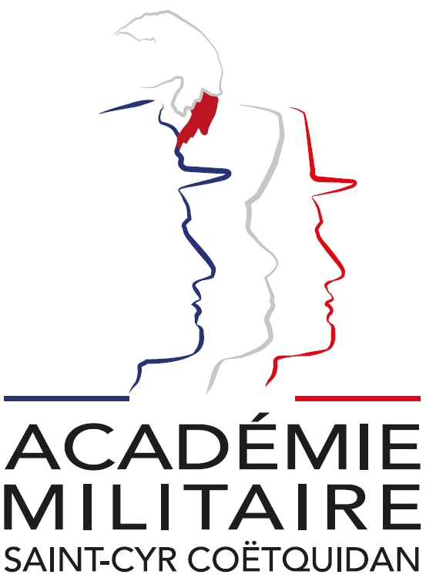

International Spring Semester
2027

REACT: Robotics, Embedded systems, AI, Cybersecurity and Telecommunications
Institutional Data Sheet
Erasmus ID code | F GUER01
Erasmus+ Coordinator | M. Emmanuel Berberian  E-mail: cyr.international@st-cyr.terre-net.defense.gouv.fr  Phone: +33 2 97 70 73 75
Dates | Arrival date: January 14-15, 2027 (Please respect these dates)  Start of the course: January 18, 2027  End of the course: June 04, 2027  Return day: June 07-08, 2027  Dates may be subject to change
Student Requirements | - B2 level in English  - Bachelor of Science (or equivalent)
Documents required for the application | - Application form  - Medical certificate  - Reduced medical booklet  - ID or Passport scan  - 1 ID photo
Application deadline | All applications must be submitted by December 04th, 2026.
Meals & Accommodations | According to EMILYO-LoD 5 (framework), accommodation, meals, and other expenses in relation to the education are free of charge for members of European Union Basic Officer Education Institutions (http://www.emilyo.eu/node/982).
Additional remarks | All incoming cadets must reach Rennes by their own means. The cadets will be picked up at Rennes airport or train station by a shuttle/bus.  Due to limited availability of vehicles, there will be only one pick-up per day; so be aware that you may have to wait a bit if you arrive early.

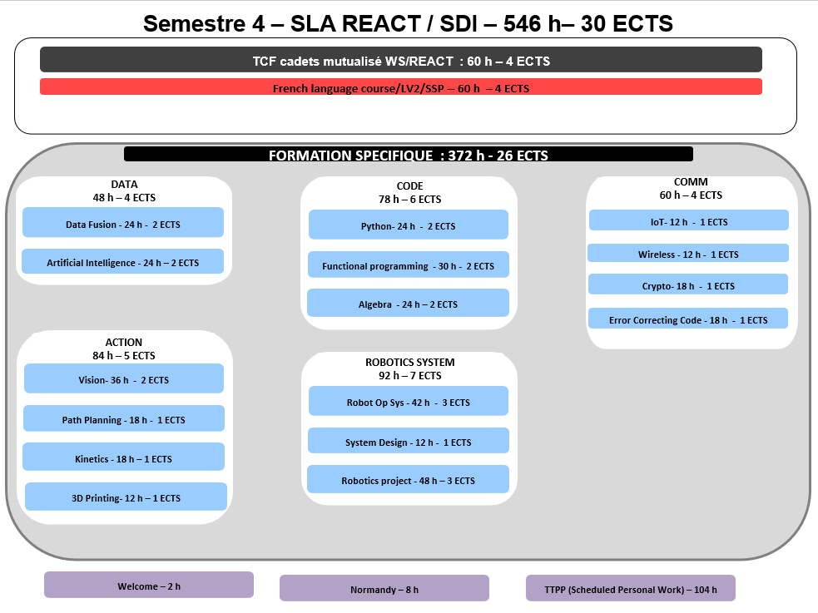

REACT
Robotics, Embedded systems, AI, Cybersecurity and Telecommunications

Headed by Dr. Jean (John) MOTSCH, PhD, Associate Professor
jean.motsch@st-cyr.terre-net.defense.gouv.fr

Prerequisite

- Bachelor of science
- 6 semesters
- 180 ECTS
- Working Language: English

REACT at a glance

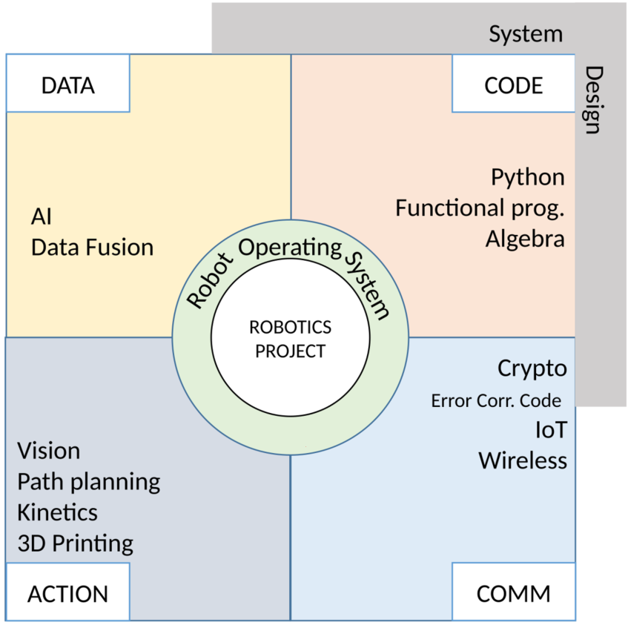
Course I

Course title | Common Module
Course duration | 60 | ECTS Credits | 4
Course objectives  (target skills) | This module is shared with the International Spring Semester 2026 – War Studies and gives the cadets the opportunity to discover more about France and its culture.
Detailed course content | - French as a foreign language [4 ECTS]  - Sport activities  - Staff trip on the Normandy D-Day sites
Methods /Teaching resources | French language course
Assessment criteria | //
Professor’s name | Ms. Cabillic and Pentecouteau

Course II
Course title | DATA
Course duration | 48 | ECTS Credits | 4
Course objectives
(target skills)
Detailed course content | - Data Fusion (24h) [2 ECTS]  - Basics of probability and random variables  - Gaussian distribution and gaussian vectors  - Bayesian estimation principles  - Kalman filter: prediction and update steps  - Practical implementation in Python  - Artificial Intelligence (24h) [2 ECTS]  - Core ideas in machine learning  - From single layer perceptron to multilayer perceptron  - Understanding optimization, generalization and overfitting  - Implementation from scratch and using library in Python  - Experimenting with Python notebooks
Methods /Teaching resources | Lecture, Tutorials, Lab sessions
Assessment criteria | Written exam and small group work
Professor’s name | DAFU : Dr. Erwan Hillion, PhD  ARTI : Dr. Maxime Nguyen, PhD

Course III

Course title | ACTION
Course duration | 84 | ECTS Credits | 5
Course objectives
(target skills)
Detailed course content | - Vision (36h) [2 ECTS]  - Image processing and feature extraction  - Computer vision and 3D reconstruction  - Object detection using neural networks  - Image-based visual servoing  - Path planning (18h) [1 ECTS]  - Introduction and (missile) waypoint guidance laws  - Trajectory guidance with Epuck and Turtlebot  - Combinatorial path planning  - Probabilistic path planning  - Kinetics (18h) [1 ECTS]  - Kinetics of points and rigid bodies  - Angular momentum and center of mass theorems  - Static equilibrium of a rigid body  - Basics of articulated systems  - CAD and 3D printing (12h) [1 ECTS]  - Introduction and product life cycle  - Overview of manufacturing processes  - 3D printing processes:  - Focus on FDM and SLA  - Design for additive manufacturing
Methods /Teaching resources | Lecture, Tutorials, Lab sessions
Assessment criteria | Written exam and small group work
Professor’s name | VISO : Dr. Jean Motsch, PhD  CADP : Dr. Pierrick Malecot, PhD  PAPL : Dr. Le Menec, PhD  KINO : Dr. Pierrick Malecot, PhD

Course IV

Course title | CODE
Course duration | 78 | ECTS Credits | 6
Course objectives
(target skills)
Detailed course content | - Python coding (24h) [2 ECTS]  - Structured programming  - Data structures  - Objects and classes  - Advanced concepts, modules, libraries  - Functional programming (30h) [2 ECTS]  - Mindset and Haskell toolchain  - Pure functions, recursion, high-order functions  - Lists and tuples  - Pattern matching, algebraic data types, type inference  - Effect management with types, basic monads  - Algebra (24h) [2 ECTS]  - Arithmetics  - Z/nZ fields  - Finite fields  - Linear algebra on finite fields
Methods /Teaching resources | Lecture, Tutorials, Lab sessions
Assessment criteria | Written exam and small group work
Professor’s name | PYCO : Dr. Lionel Touseau, PhD  FUNP : Dr. Hanh Nhi Tran, PhD  ALGA : Dr. Didier Alquié, PhD

Course V

Course title | COMM
Course duration | 60 | ECTS Credits | 4
Course objectives
(target skills)
Detailed course content | - Internet of things (12h) [1 ECTS]  - Characteristics, uses cases and devices  - Device-to-device communications  - Cyber-space, -security, -defense and -awareness  - Threats, cyberattacks and protection methods  - IoT security overview  - IoT security application  - Wireless communications (12h) [1 ECTS]  - Radio signal spectrum and communications standards  - Modulation/demodulation and digital modulation techniques  - Propagation channel  - Multicarrier modulation  - Software-defined radio  - Cryptography (18h) [1 ECTS]  - Attacker and security model  - Symmetric encryption  - Asymmetric encryption  - Symmetric integrity and hashing  - Signatures  - Authentication  - Quantum computing and cryptography  - Error correcting code (18h) [1 ECTS]  - Information protection  - Combinatorial point of view of error correcting codes  - Algebraic point of view of linear codes  - Polynomial point of view of cyclic codes
Methods /Teaching resources | Lecture, Tutorials, Lab sessions
Assessment criteria | Written exam and small group work
Professor’s name | IOTS : Dr. Staddon, PhD  WCOM : Dr. Jérôme Le Masson, PhD  CRYP : Dr. Didier Alquié, PhD  ECCE : Dr. Didier Alquié, PhD

Course VI

Course title | ROBOTICS SYSTEM
Course duration | 92 | ECTS Credits | 7
Course objectives
(target skills)
Detailed course content | - Mobile robot operating system (42h) [3 ECTS]  - ROS2 concepts and communications  - Understanding Gazebo simulator  - Understanding of RQT  - Navigation in ROS2  - Path planning in ROS2  - System design (12h) [1 ECTS]  - Introduction for systems engineering  - Systems engineering processes  - Concept development and requirements  - System analysis  - System architecture  - Application to the mobile robot project  - Mobile robotics project (48h) [3 ECTS]  - Wrapping-up of all competences acquired
Methods /Teaching resources | Lecture, Tutorials, Lab sessions
Assessment crieria | Written exam and small group work
Professor’s name | MROS : Dr. Yves Bergeon, PhD  SYDE : Dr. Hanh Nhi Tran, PhD  MROB : Dr. Yves Bergeon, PhD, and Dr. Jean Motsch, PhD

Documents required:

- Application Form (p. 9)

- Medical Certificate (p. 11)

- Reduced Medical Booklet (p. 12 – p.13)

Application Form
Insert Photo Here

(preferably a passport picture in jpg-format or attach the picture to the mail)

REMARKS:

- fill in 1 application form for 1 person;
- insert applicant’s photo;
- choose the course (and, if applicable, the module(s)) you would like to attend;
- send the completed form to: cyr.international@st-cyr.terre-net.defense.gouv.fr
Course
War Studies (in English) | REACT (in English)
☐ | ☐

Male  (click to mark) | Female  (click to mark) | Rank | FAMILY NAME | First name(s)
☐ | ☐

Date of birth  (DD/MM/YYYY) | Place of birth (City + Country) | Nationality
Click for date

Branch of Service | Sending institution’s name | Passport or ID number | Passport or ID validity until  (DD/MM/YYYY)
 |  |  | Click for date

Phone number  (please include country code) | E-mail address

Arrival
… at Rennes airport  (click to mark) | … at Rennes train station  (click to mark) | … by (own) car  (click to mark) | License plate  (If arrival by car) | Date | Time
☐ | ☐ | ☐ |  | Click for date

Departure
… at Rennes airport  (click to mark) | … at Rennes train station  (click to mark) | … by (own) car  (click to mark) | Date | Time
☐ | ☐ | ☐ | Click for date

Special dietary or food requirements due to medical or religious reasons  (click to mark) |  | If yes, please specify food you cannot eat
No | Yes
☐ | ☐

Additional remarks
(need for special equipment, special travel arrangements, etc.)

POC at sending institution
Male  (click to mark) | Female  (click to mark) | Rank, ac. degree(s) | FAMILY NAME | First name(s)
☐ | ☐
POC’s phone number (include country code) |  |  | POC’s e-mail address
FRENCH MINISTRY OF DEFENSE AND VETERANS

-------------------------

MILITARY HEALTH SERVICE

--------------------------

MEDICAL CERTIFICATE
(n°620-4/1)

Last name: First name:

Birth date: Rank:

APTITUDES | Medical decision
General

Abroad & overseas

Paratrooper

Commando

Job’s restriction details
(if needed)

CONCLUSION: Date:
⁭ Aptitude without restrictions
⁭ Aptitude with restrictions Physician’s signature & stamp:
⁭ Inability

Reduced Medical Booklet

Last name: First name:

Birth date: Rank:

Medical background
- Family:

- Medical:

- Surgical:

- Allergy:

Treatment:

Current medical condition:

Work incapacity:

Height: Weight:

Blood pressure: Pulse:

VACCINATION:

TYPE | Date of 1st injection | 2nd injection | 3rd injection
BCG
Diphtheria-Tetanus-Polio-Pertussis
Meningitis (A + C)
Hepatitis B
Measles-Mumps-Rubella
INFLUENZAE (H1N1 and seasonal)
Meningococcal Tetravalent (A + C + Y + W135
Typhoid
Hepatitis A
Yellow fever

Date: Physician’s stamp and signature:

