
INVITATION 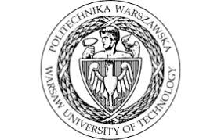

Dear Colleagues,
On behalf of the Organizing Committee,
I am honoured to invite you to participate in the XXII International Technical Systems Degradation Conference, which will be held on April 08-10, 2026, in Liptovský Mikuláš, Slovakia.
The aim of the conference is to present the latest achievements in the field of modelling and simulation of mechanical system failures, diagnostics of fatigue and low-energy failures, safety of technical systems as well as diagnostics of the technical condition and development of structural failures. An important part of the conference topics are also issues in the field of broadly understood exploitation, with particular emphasis on the selection of an effective strategy and methods for diagnosing and forecasting the condition and evolution of damage, as well as issues related to security and defence understood both in the military and forensic sense.
IMPORTANT DATES AND REGISTRATION
• 02.03.2026 declaration of participation (by web-page);
• 06.03.2026 notification of paper acceptance to oral or poster presentation;
• 15.03.2026 Extended Abstracts submitting (1-4 pages), by e-mail, for inserting in the pre-conference proceedings; Payment of registration fee;
• 21.06.2026 deadline for submission of full-length papers according to guidelines by journals web-pages;
• 30.09.2026 editing of post-conference papers and sending to the selected journal's offices for printing materials from the conference.
Detailed information can be found at the conference website and in the attached Call for Papers:
https://www.aos.sk/tsd
Yours Sincerely,
Co-chairman of Organizing Committee
Marcin Jasiński

