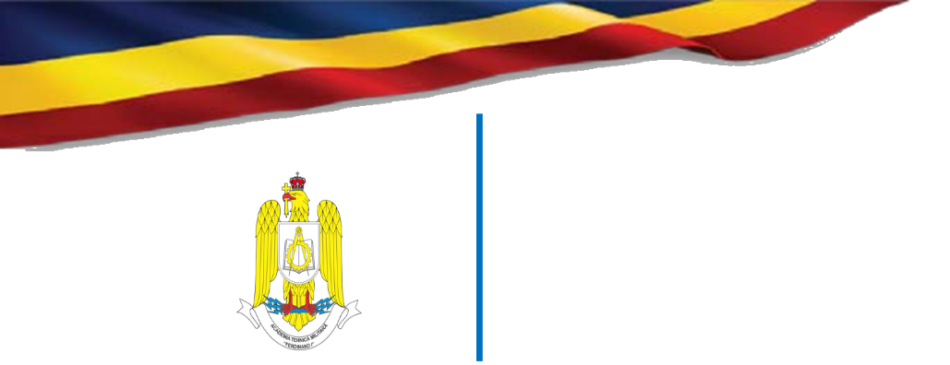
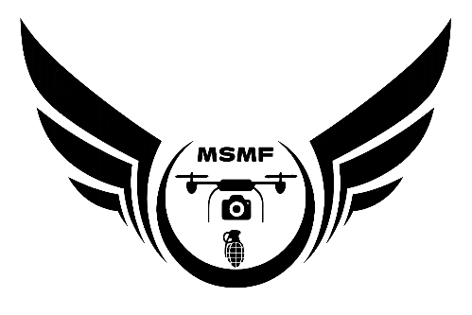
Military Technical Academy „Ferdinand I”
George Coşbuc Boulevard no. 39-49, Sector 5
Bucharest, Romania
Phone: (+40) 21 335 46 60
Email: relatii.publice@mta.ro

MSMF 2026 - Military Student Drone Competition (3rd Edition)

Military Student Multirotor Fest

27 – 30 April 2026

Bucharest, Romania

REGISTRATION FORM

Team name:
Rank, Name and Surname of members and their role within the team:
1. Std. serg. John Adams – UAV pilot – team captain
2. Std. serg. Jim Anderson – UAV electronist – team member
3.
4.
Rank, Name and Surname of the coordinating teacher
Phone number and email address of the coordinating teacher
Phone:
Email:
Affiliation:
University:
Department:

After completion, the form is sent to the following email address: cristian.vidan@mta.ro, phone: (+40) 767739318.
IMPORTANT: Registrations are open until 01.03.2026.

