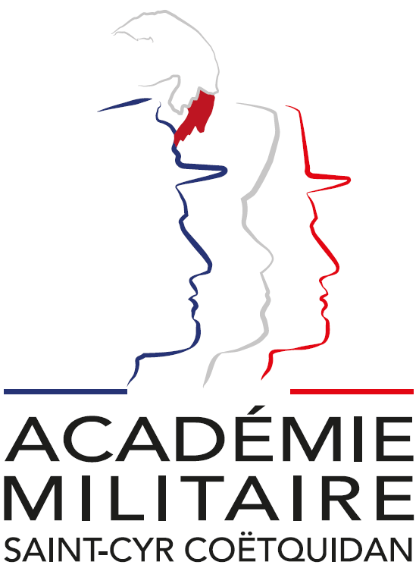

International Spring Semester
2026

War Studies

Institutional Data Sheet
Erasmus ID code | F GUER01
Erasmus+ Coordinator | First Lieutenant (OF-1) Charlie Offerlin  E-mail: cyr.international@st-cyr.terre-net.defense.gouv.fr  Phone: +33 2 97 70 73 75
Dates | Arrival date: January 19-20, 2026 (Please respect these dates)  Start of the course: January 22, 2026  End of the course: June 12, 2026  Return day: June 13-14, 2026  Dates may be subject to change
Student Requirements | - B2 level in English  - Bachelor’s degree (or equivalent)
Documents required for the application | - Application form  - Medical certificate  - Reduced medical booklet  - ID or Passport scan  - 1 ID photo
Application deadline | All applications must be submitted by December 12th, 2025.
Meals & Accommodations | According to EMILYO-LoD 5 (framework), accommodation, meals, and other expenses in relation to the education are free of charge for members of European Union Basic Officer Education Institutions (http://www.emilyo.eu/node/982).
Remarks | All incoming cadets must reach Rennes by their own means. The cadets will be picked up at Rennes airport or train station by a shuttle/bus. Due to limited availability of vehicles, there will be only one pick-up per day; so be aware that you may have to wait a bit if you arrive early.

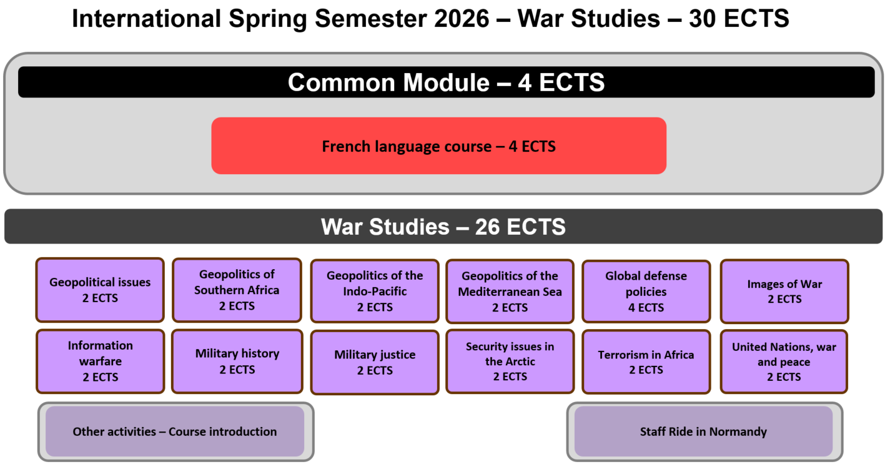
War Studies: Course Syllabus 2026

Headed by M. Gwenaël GUYON, Assoc. Prof. in Law
gwenael.guyon@st-cyr.terre-net.defense.gouv.fr

Geopolitical issues

This module includes group research work. Divided into groups of different nationalities, cadets will prepare a presentation on a specific geopolitical issue.

Geopolitics of Southern Africa

This course will examine Geopolitics and insurrections in Southern Africa, stressing examples of South Africa, Namibia, Mozambique and Angola. Counter-insurrections, Military issues, Security issues and Piracy, among others, will be at the heart of this class.

Geopolitics of the Indo-pacific

The aim of the course is to have a study in depth of both concept and reality by focusing on main actors : states such as the US, China, India, Japan, Australia, France and the EU ; regional organisations ; TransNational Companies ; NGOs and transnational organised crime. The key issues will be regional order, strategy and vision, diplomacy, policies, cooperation and integration, military tensions, piracy, terrorism, energy resources, natural resources, major shipping routes, submarine cables, migration patterns and remittances. The methodology is based on many case-studies of subregions and strategic chokepoints : the Malacca Strait, the Taiwan Strait, the South China Sea, the East China Sea, the Indian Ocean, the horn of Africa and the Strait of Bab-el-Mandeb, the Strait of Hormuz, the Indian subcontinent, Australia, New-Zealand and the Pacific islands. Teamwork, cooperative spirit and team communication skills will be required.

Geopolitics of the Mediterranean Sea

The objective of the course is to undertake a comprehensive examination of the security challenges and policies that pertain to the Mediterranean Sea. The key issues are set to be regional order, strategy and vision, diplomacy, policies, cooperation and integration, military tensions, terrorism, energy resources, natural resources, major shipping routes, submarine cables, migration patterns and remittances.

Global Defense policies

This module involves group research work. Divided into groups by country, cadets will prepare a presentation on their country's defence policy and write a dissertation. They will defend their work in a public presentation before civilian and military executives from the AMSCC.

Images of War

The aim of the course is to discover the weight of representations and propaganda on the conduct of war. What are the relations between the graphic arts and war. How have arts been used to the conduct of war?

Information warfare

The aim of this course is to study homeland security in the US since 2001 and to address new challenges in terms of security and war: use and management of information and communication technology, cyber, medias, fake news, influences, propaganda, disinformation, etc.

Military History

The course under discussion will be dedicated to an examination of the history of war and the history of European armies from 1918 to 1945, with a particular focus on the military histories of the United Kingdom, Germany and France. The primary focus of this course is on the construction, reconstruction, and reform of armed forces following a conflict or in anticipation of future hostilities.

Military Justice

By means of a comparative analysis of legal systems, this course will examine the overarching principles of military justice (procedure, offences and punishments, human rights of members of armed forces, etc.). Contemporary issues will also be addressed, such as the evolution and functioning of military justice in wartime (Israel, Ukraine).

Security issues in the Arctic

This course provides an introduction to security and geopolitic issues in Arctic. Some of the key issues will be political and military cooperation, military exercises, geopolitical tensions, economic integration, strategic economic activities (fishing, mining and shipping) and climate change.

Terrorism in Africa

The course is about the many security aspects of the African continent. It focuses on military issues in different areas like Western Africa or the Horn of Africa. It also insists on current dynamics : radicalization, terrorism, jihadism, political instability, border conflicts, resources management, food security or climate change. It will encompass the logics of players in international relations : local and federal authorities, foreign powers (the US, the UK, France, Russia or China), the international community (UNO, UNHCR, UNICEF), NGOs or TNCs.

United Nations, war and peace

The present course provides a comprehensive overview of the United Nations, encompassing their organisational structure, operational processes, and the missions to which they are committed. The course is taught by a former head of the French delegation to the UN.

Documents required:

- Application Form (p. 8)

- Medical Certificate (p. 10)

- Reduced Medical Booklet (p. 11 – p.12)

Application Form
Insert Photo Here

(preferably a passport picture in jpg-format or attach the picture to the mail)

REMARKS:

- fill in 1 application form for 1 person;
- insert applicant’s photo;
- choose the course (and, if applicable, the module(s)) you would like to attend;
- send the completed form to: cyr.international@st-cyr.terre-net.defense.gouv.fr
Course
War Studies (in English) | REACT (in English)
☐ | ☐

Male  (click to mark) | Female  (click to mark) | Rank | FAMILY NAME | First name(s)
☐ | ☐

Date of birth  (DD/MM/YYYY) | Place of birth (City + Country) | Nationality
Click for date

Branch of Service | Sending institution’s name | Passport or ID number | Passport or ID validity until  (DD/MM/YYYY)
 |  |  | Click for date

Phone number  (please include country code) | E-mail address

Arrival
… at Rennes airport  (click to mark) | … at Rennes train station  (click to mark) | … by (own) car  (click to mark) | License plate  (If arrival by car) | Date | Time
☐ | ☐ | ☐ |  | Click for date

Departure
… at Rennes airport  (click to mark) | … at Rennes train station  (click to mark) | … by (own) car  (click to mark) | Date | Time
☐ | ☐ | ☐ | Click for date

Special dietary or food requirements due to medical or religious reasons  (click to mark) |  | If yes, please specify food you cannot eat
No | Yes
☐ | ☐

Additional remarks
(need for special equipment, special travel arrangements, etc.)

POC at sending institution
Male  (click to mark) | Female  (click to mark) | Rank, ac. degree(s) | FAMILY NAME | First name(s)
☐ | ☐
POC’s phone number (include country code) |  |  | POC’s e-mail address
FRENCH MINISTRY OF DEFENSE AND VETERANS

-------------------------

MILITARY HEALTH SERVICE

--------------------------

MEDICAL CERTIFICATE
(n°620-4/1)

Last name: First name:

Birth date: Rank:

APTITUDES | Medical decision
General

Abroad & overseas

Paratrooper

Commando

Job’s restriction details
(if needed)

CONCLUSION: Date:
⁭ Aptitude without restrictions
⁭ Aptitude with restrictions Physician’s signature & stamp:
⁭ Inability

Reduced Medical Booklet

Last name: First name:

Birth date: Rank:

Medical background
- Family:

- Medical:

- Surgical:

- Allergy:

Treatment:

Current medical condition:

Work incapacity:

Height: Weight:

Blood pressure: Pulse:

VACCINATION:

TYPE | Date of 1st injection | 2nd injection | 3rd injection
BCG
Diphtheria-Tetanus-Polio-Pertussis
Meningitis (A + C)
Hepatitis B
Measles-Mumps-Rubella
INFLUENZAE (H1N1 and seasonal)
Meningococcal Tetravalent (A + C + Y + W135
Typhoid
Hepatitis A
Yellow fever

Date: Physician’s stamp and signature:

