

International Spring Semester
2026

REACT: Robotics, Embedded systems, AI, Cybersecurity and Telecommunications
Institutional Data Sheet
Erasmus ID code | F GUER01
Erasmus+ Coordinator | First Lieutenant (OF-1) Charlie Offerlin  E-mail: cyr.international@st-cyr.terre-net.defense.gouv.fr  Phone: +33 2 97 70 73 75
Dates | Arrival date: January 19-20, 2026 (Please respect these dates)  Start of the course: January 22, 2026  End of the course: June 12, 2026  Return day: June 13-14, 2026  Dates may be subject to change
Student Requirements | - B2 level in English  - Bachelor of Science (or equivalent)
Documents required for the application | - Application form  - Medical certificate  - Reduced medical booklet  - ID or Passport scan  - 1 ID photo
Application deadline | All applications must be submitted by December 12th, 2025.
Meals & Accommodations | According to EMILYO-LoD 5 (framework), accommodation, meals, and other expenses in relation to the education are free of charge for members of European Union Basic Officer Education Institutions (http://www.emilyo.eu/node/982).
Additional remarks | All incoming cadets must reach Rennes by their own means. The cadets will be picked up at Rennes airport or train station by a shuttle/bus.  Due to limited availability of vehicles, there will be only one pick-up per day; so be aware that you may have to wait a bit if you arrive early.

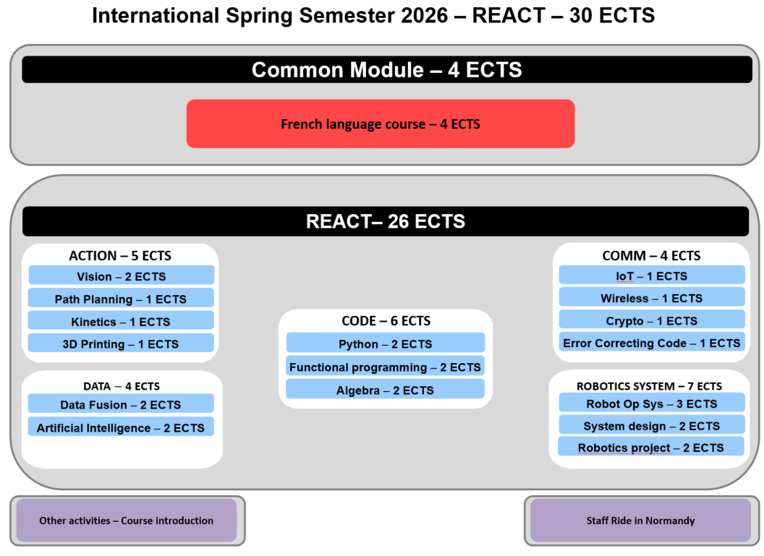

REACT: Course Syllabus 2026
Headed by Dr. Jean (John) MOTSCH, PhD, Associate Professor
jean.motsch@st-cyr.terre-net.defense.gouv.fr
*REACT stands for Robotics, Embedded systems, AI, Cybersecurity and Telecommunications.

Prerequisite

- Bachelor of science
- 6 semesters
- 180 ECTS
- Working Language: English

Common Module [4 ECTS]

This module is shared with the International Spring Semester 2026 – War Studies and gives the cadets the opportunity to discover more about France and its culture. It includes:
- French as a foreign language [4 ECTS]
- Sport activities
- Staff trip on the Normandy D-Day sites

REACT at a glance

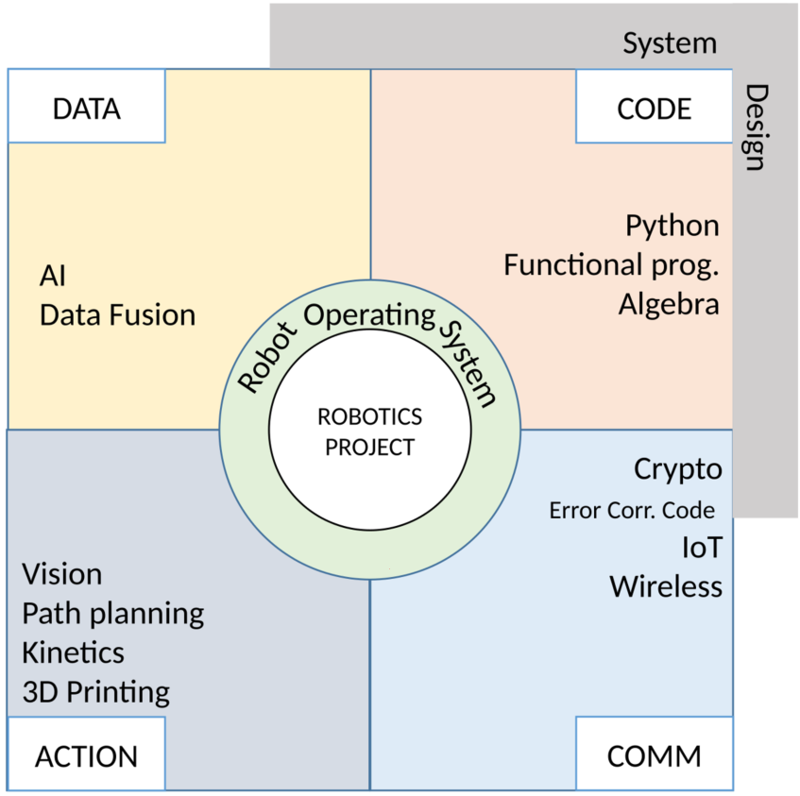

Package ACTION [5 ECTS]

- Vision [2 ECTS]
  - Image processing and feature extraction
  - Computer vision and 3D reconstruction
  - Object detection using neural networks
  - Image-based visual servoing
- Path planning [1 ECTS]
  - Introduction and (missile) waypoint guidance laws
  - Trajectory guidance with Epuck and Turtlebot
  - Combinatorial path planning
  - Probabilistic path planning
- Kinetics [1 ECTS]
  - Kinetics of points and rigid bodies
  - Angular momentum and center of mass theorems
  - Static equilibrium of a rigid body
  - Basics of articulated systems
- CAD and 3D printing [1 ECTS]
  - Introduction and product life cycle
  - Overview of manufacturing processes
  - 3D printing processes:
  - Focus on FDM and SLA
  - Design for additive manufacturing

Package CODE [6 ECTS]

- Python coding [2 ECTS]
  - Structured programming
  - Data structures
  - Objects and classes
  - Advanced concepts, modules, libraries
- Functional programming [2 ECTS]
  - Mindset and Haskell toolchain
  - Pure functions, recursion, high-order functions
  - Lists and tuples
  - Pattern matching, algebraic data types, type inference
  - Effect management with types, basic monads
- Algebra [2 ECTS]
  - Arithmetics
  - Z/nZ fields
  - Finite fields
  - Linear algebra on finite fields

Package COMMUNICATIONS [4 ECTS]

- Internet of things [1 ECTS]
  - Characteristics, uses cases and devices
  - Device-to-device communications
  - Cyber-space, -security, -defense and -awareness
  - Threats, cyberattacks and protection methods
  - IoT security overview
  - IoT security application
- Wireless communications [1 ECTS]
  - Radio signal spectrum and communications standards
  - Modulation/demodulation and digital modulation techniques
  - Propagation channel
  - Multicarrier modulation
  - Software-defined radio
- Cryptography [1 ECTS]
  - Attacker and security model
  - Symmetric encryption
  - Asymmetric encryption
  - Symmetric integrity and hashing
  - Signatures
  - Authentication
  - Quantum computing and cryptography
- Error correcting code [1 ECTS]
  - Information protection
  - Combinatorial point of view of error correcting codes
  - Algebraic point of view of linear codes
  - Polynomial point of view of cyclic codes

Package DATA [4 ECTS]

- Data Fusion [2 ECTS]
  - Basics of probability and random variables
  - Gaussian distribution and gaussian vectors
  - Bayesian estimation principles
  - Kalman filter: prediction and update steps
  - Practical implementation in Python
- Artificial Intelligence [2 ECTS]
  - Core ideas in machine learning
  - From single layer perceptron to multilayer perceptron
  - Understanding optimization, generalization and overfitting
  - Implementation from scratch and using library in Python
  - Experimenting with Python notebooks

Package ROBOTICS SYSTEM [7 ECTS]

- Mobile robot operating system [3 ECTS]
  - ROS2 concepts and communications
  - Understanding Gazebo simulator
  - Understanding of RQT
  - Navigation in ROS2
  - Path planning in ROS2
- System design [2 ECTS]
  - Introduction for systems engineering
  - Systems engineering processes
  - Concept development and requirements
  - System analysis
  - System architecture
  - Application to the mobile robot project
- Mobile robotics project [2 ECTS]
  - Wrapping-up of all competences acquired

Documents required:

- Application Form (p. 9)

- Medical Certificate (p. 11)

- Reduced Medical Booklet (p. 12 – p.13)

Application Form
Insert Photo Here

(preferably a passport picture in jpg-format or attach the picture to the mail)

REMARKS:

- fill in 1 application form for 1 person;
- insert applicant’s photo;
- choose the course (and, if applicable, the module(s)) you would like to attend;
- send the completed form to: cyr.international@st-cyr.terre-net.defense.gouv.fr
Course
War Studies (in English) | REACT (in English)
☐ | ☐

Male  (click to mark) | Female  (click to mark) | Rank | FAMILY NAME | First name(s)
☐ | ☐

Date of birth  (DD/MM/YYYY) | Place of birth (City + Country) | Nationality
Click for date

Branch of Service | Sending institution’s name | Passport or ID number | Passport or ID validity until  (DD/MM/YYYY)
 |  |  | Click for date

Phone number  (please include country code) | E-mail address

Arrival
… at Rennes airport  (click to mark) | … at Rennes train station  (click to mark) | … by (own) car  (click to mark) | License plate  (If arrival by car) | Date | Time
☐ | ☐ | ☐ |  | Click for date

Departure
… at Rennes airport  (click to mark) | … at Rennes train station  (click to mark) | … by (own) car  (click to mark) | Date | Time
☐ | ☐ | ☐ | Click for date

Special dietary or food requirements due to medical or religious reasons  (click to mark) |  | If yes, please specify food you cannot eat
No | Yes
☐ | ☐

Additional remarks
(need for special equipment, special travel arrangements, etc.)

POC at sending institution
Male  (click to mark) | Female  (click to mark) | Rank, ac. degree(s) | FAMILY NAME | First name(s)
☐ | ☐
POC’s phone number (include country code) |  |  | POC’s e-mail address
FRENCH MINISTRY OF DEFENSE AND VETERANS

-------------------------

MILITARY HEALTH SERVICE

--------------------------

MEDICAL CERTIFICATE
(n°620-4/1)

Last name: First name:

Birth date: Rank:

APTITUDES | Medical decision
General

Abroad & overseas

Paratrooper

Commando

Job’s restriction details
(if needed)

CONCLUSION: Date:
⁭ Aptitude without restrictions
⁭ Aptitude with restrictions Physician’s signature & stamp:
⁭ Inability

Reduced Medical Booklet

Last name: First name:

Birth date: Rank:

Medical background
- Family:

- Medical:

- Surgical:

- Allergy:

Treatment:

Current medical condition:

Work incapacity:

Height: Weight:

Blood pressure: Pulse:

VACCINATION:

TYPE | Date of 1st injection | 2nd injection | 3rd injection
BCG
Diphtheria-Tetanus-Polio-Pertussis
Meningitis (A + C)
Hepatitis B
Measles-Mumps-Rubella
INFLUENZAE (H1N1 and seasonal)
Meningococcal Tetravalent (A + C + Y + W135
Typhoid
Hepatitis A
Yellow fever

Date: Physician’s stamp and signature:

