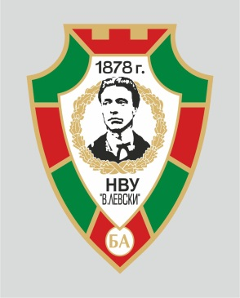
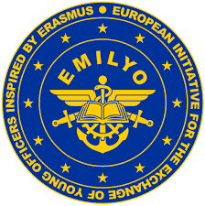
ERASMUS+ INTERNATIONAL STAFF WEEK

VASIL LEVSKI NATIONAL MILITARY UNIVERSITY

ERASMUS+ PROGRAMME
12.10.2026 – 16.10.2026
DRAFT PROGRAM

Monday, October 12
 | Arrival of participants |  | Hotels
Tuesday, October 13
09.00 – 09.30 | Registration HQ Building
09.30 – 10.15 | International Staff Week Opening  Key-note speeches  - Rector – BRIG. GEN. Stancho Kaykov, PhD  - Presentation by host institution - Vasil Levski NMU and Erasmus+ Programme at the University - COL Assoc. Prof. Nevena Atanasova-Krasteva, PhD and Major Hristo Minchev  Group photo in front of the Headquarters |  | Ritual Hall –  HQ Building
10.15 – 10.45 | Coffee break |  | Cafeteria –  HQ Buliding
10.45 – 11.30 | Visit to Vasil Levski NMU museum and church and Group photo in front of the Statue of Vasil Levski
11.30 – 12.30 |  |  | Briefing Hall –  Academic Building 1
11.30 – 12.30 | - Presentations by partner institutions (each institution has to prepare a 10-minute presentation/ video) | In alphabetical order  by country
12.30 – 14.00 | Lunch
14.00 – 16.00 | - Presentations by partner institutions (each institution has to prepare a 10-minute presentation/ video) | In alphabetical order  by country | Briefing Hall –  Academic Building 1
16.00 – 17.00 | Free time
Wednesday, October 14
10.00 – 17.30 | Visit to the town of Veliko Tarnovo, Tsarevets Fortress, Holy forthy martyrs church, the museum with the wax figures. |  | Programme*
Thursday, October 15
09.00 – 12.00 | STA – Teaching mobility |  | Academic Building 1
09.30 – 12.00 | Workshop: Lecture/Discussion with topics about the Erasmus programme and implementation: exchange of good practices; challenges related to the BIP mobility. |  | Briefing Hall – Academic Building 1
10.30 -11.00 | Coffee break
12.00 – 13.00 | Closing Ceremony.  Certificates of the participants in the International Week |  | Ritual Hall –  HQ Building
13.30 – 19.30 | Free time
19.30 – 22.00 | Closing dinner |  |  | Restaurant/TBD
Friday, October 16
 | Free time/Departure

