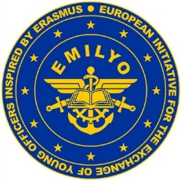 |  |  | APPLICATION FORM  ERASMUS+ INTERNATIONAL  STAFF WEEK  Vasil Levski  NATIONAL MILITARY UNIVERSITY  Veliko Tarnovo, BULGARIA  October 12 – 16, 2026 |  |  | 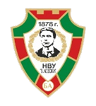
Male |  | Female |  | Rank | Family name | First name

Date of birth | Nationality | Passport number | Passport expiration date

Branch of Service (if available) | Sending institution

Teaching/training mobility | Mobile phone number | e-mail address
Arrival at  Sofia Airport | Other Arrival | On (arrival date) | At (arrival time if available)
* | * | * | *
Departure from  Sofia Airport | Other Departure | On (departure date) | At (departure time if available)
* | * | * | *

Special dietary or food restrictions due to medical or religious reasons | If yes, please specify food you cannot eat

Additional remarks (need for special equipment, special travel arrangements, ….)

Point of contact (POC) of sending institute
Male | Female | Rank | Family name | First name
POC’s phone number | POC’s e-mail address

* If you do not know your flight/travelling data at this stage you must send them later.
Please send the application form to
Major Hristo Minchev, e-mail address: erasmus.nmu@gmail.com

