 | NIKOLA VAPTSAROV NAVAL ACADEMY | Erasmus+ BIP – fall semester

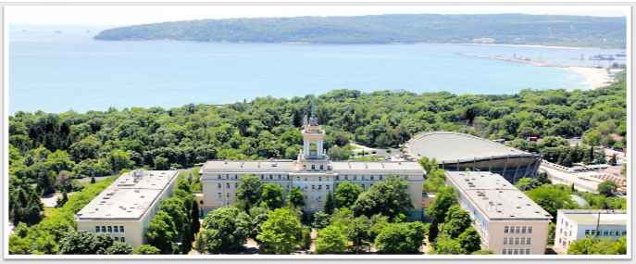

Name of the BIP: AI in the Sky
Organizer:  Nikola Vaptsarov Naval Academy | ECTS credits for participating students:  3
Online period:  Two weeks theory, Moodle at any venue | Onsite period:  One week, at the NVNA IT Dept. for review, discussions and workshop; Karantina Sea camp for on-site practice
Academic coordinator:  Assos. Prof. Veselin Atanasov, PhD. | Administrative coordinator:  erasmus@nvna.eu
Academic requirements:  2nd or 3rd year of study with basic knowledge in Information Technologies | Language requirement for students: English B2
Nominations and number of students accepted:
Up to 15. For nominating, please send your students information to erasmus@nvna.eu
Content of the onsite program:
Main focus: Integration of AI with drones.
Main topics: Fundamental AI principles, hands-on experience with tools for processing images and video streams, experimenting with real-time video analytics using drone footage.
Main goal: Practical learning through innovative projects, enabling participants to develop solutions for real-time data processing and extraction of information in aerial scenarios.
By fostering collaboration and creativity, the workshop aims to inspire new ideas at the intersection of AI and drone technologies.
Prerequisites for the participants:
Proficiency in Python – Basic to intermediate knowledge of Python programing, abilities to write, debug and understand the code
Basic knowledge of Artificial Intelligence – Understanding of basic AI concepts, such as machine learning, neural networks and data processing technics
System thinking – Ability to analyze and design of complex systems, understanding their components and how they interact
Familiarity with drones – Knowledge of drone technology, their operation, functionality and areas of application

*Rem: For applicants who cannot meet those prerequisites the two weeks online session can be expanded to cover the prerequisites. In such a case the students have to be detached from other studding activities and to focus just to the online course.

Onsite Schedule
MONDAY | - LECTURE-DISCUSSION ON AI
TUESDAY | - WORKSHOP ON YOLO MODELS AND IMAGE RECOGNITION
WEDNESDAY | - HOW TO WORK WITH DRONES
THURSDAY | - ON SITE PRACTICE WITH DRONES AND AI
FRYDAY | - MEET VARNA

