ROMANIAN NAVAL ACADEMY “MIRCEA CEL BĂTRÂN”
1st Fulgerului street, 900218, Constanta, Romania
Tel/fax: +40241/643096
Email: international@anmb.ro

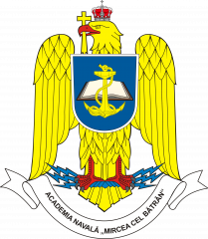

Esteemed Partners,
Dear IG Members Representatives,

In respect of the traditional cooperation framework developed between our institutions in field of military education and training programs under EMILYO framework, we are sincerely honoured to invite your cadets to participate to the module of “NAVAL POWER PLANTS”, organized as Blended Intensive Program by the Romanian Naval Academy under Erasmus+ framework, in Constanta/Romania, during 02nd to 06th of November 2026.
The online part of the course will be uploaded as prerequisite on www.marplat.eu platform, and the residential stage will be conducted in the Romanian Naval Academy facilities.
The residential activities are planned to commence on 02nd of November; therefore, we expect the students’ arrival latest by 01st of November in the evening. The course will be finalized with certification exam on 06th of November.
Romanian Naval Academy will provide during the module, free accommodation, and free meals for all attending students, based on mutual EMILYO cooperation framework. The activities will require utility uniform.
Please find attached the registration form, as to be submitted no later than 15th of September 2026. Point of contact for registration and for further administrative details: CDR. (ROU Navy) Marius CUCU, e-mail: international@anmb.ro, Fax: +40241643096.
Looking forward to welcome your cadets in Romania!

Sincerely Yours,

COMMANDANT (RECTOR) OF THE ROMANIAN NAVAL ACADEMY

REAR ADMIRAL (LH) Alecu TOMA
Associate Professor, PhD

