HELLENIC AIR FORCE ACADEMY
ΣΧΟΛΗ ΙΚΑΡΩΝ
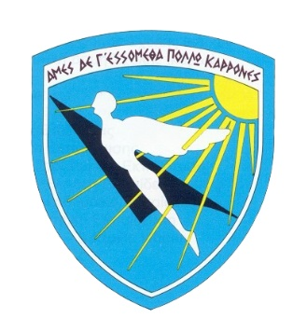




COMMON MODULE ON
SPACE APPLICATIONS FOR SECURITY AND DEFENCE

(European initiative for the exchange of young military officers, inspired by Erasmus)

Organized in Athens/Greece from the 24th to the 28th of November 2025

Admin Info

- Participation

The Common Module could attend cadets/ students/ young military officers with some previous basic knowledge about Basic knowledge of Common Security and Defence Policy.
According to the Common European Framework of Reference for Languages (CEFR) Level B1 or NATO STANAG Level 2, a good English language level is required.

- Transportation

The Hellenic Air Force Academy will provide free transportation between Athens International Airport “Eleftherios Venizelos” and the Academy at the beginning and end of the module.
Therefore, participants are kindly requested to arrange their arrival at Athens International Airport on the 23 of November 2025 NLT 18:00 and departure on the 28 of November 2025 after 17:00 (if possible). Participants will be met in the Arrival Hall of Athens International Airport according to their flight schedules by a representative of the Hellenic Air Force Academy, who will be holding a “HAFA SASD” banner.

- Accommodation

Please be informed that the Hellenic Air Force Academy will provide accommodation, only, for the participating Military International/National cadets and Young military officers from foreign countries at the Academy’s campus.

- Meals

The Hellenic Air Force Academy will provide meals for the participants who will be
accommodated at HAFA premises (Military Personnel).

- Venue

Hellenic Air Force Academy,
Dekeleia Air Base,
Acharnai,
Postal Code 13671

- Dress Code

• Arrival/Departure and Sightseeing: Casual
• Opening Ceremony/Closing Ceremony: Official Uniform (Class “A”) or equivalent for civilian participants (jacket & tie)
• Sessions: Working uniform (Class “B”) or equivalent. For civilian participants smart casual.

- Course fee

The course is free of charge.

- Registration Process

Participants are kindly requested to register by sending the attached application form to the POC no later than 20 October 2025. Registration is open on a first-come-first-served basis. All students, please consider that the access to the server for IDL (e-learning phase) will be closed down on Sunday the 23th of November 2025 (23:59 UTC).

- Point Of Contact (POC)

1st Lt Marina KONSTANTINOU
EUAFA-Mil. Erasmus Office
Hellenic Air Force Academy
Phone number: +30 210 8193844 (office) - +30 6984368733 (mobile)
Email: erasmus.hafa@haf.gr

