|  |  |  |
| --- | --- | --- |
| C:\Users\Емил Йорданов\Downloads\logo.png | NIKOLA VAPTSAROV NAVAL ACADEMY | Erasmus+ BIP – Summer 2025 |

Dear Participants,

We are pleased to announce **that BIP: “AI in the Sky”** just around the corner!

The meeting will be held in Varna, Bulgaria from **02nd June to 07th June 2025**. It will be hosted at the **Nikola Vaptsarov Naval Academy**

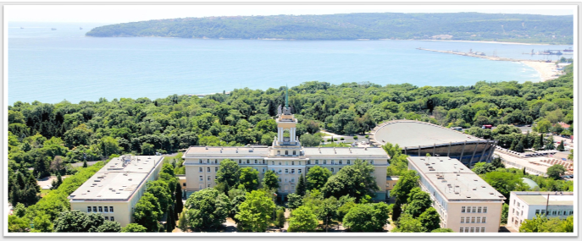

**Where is NVNA?**

**Address**: 73 Vasil Drumev Str., Varna

[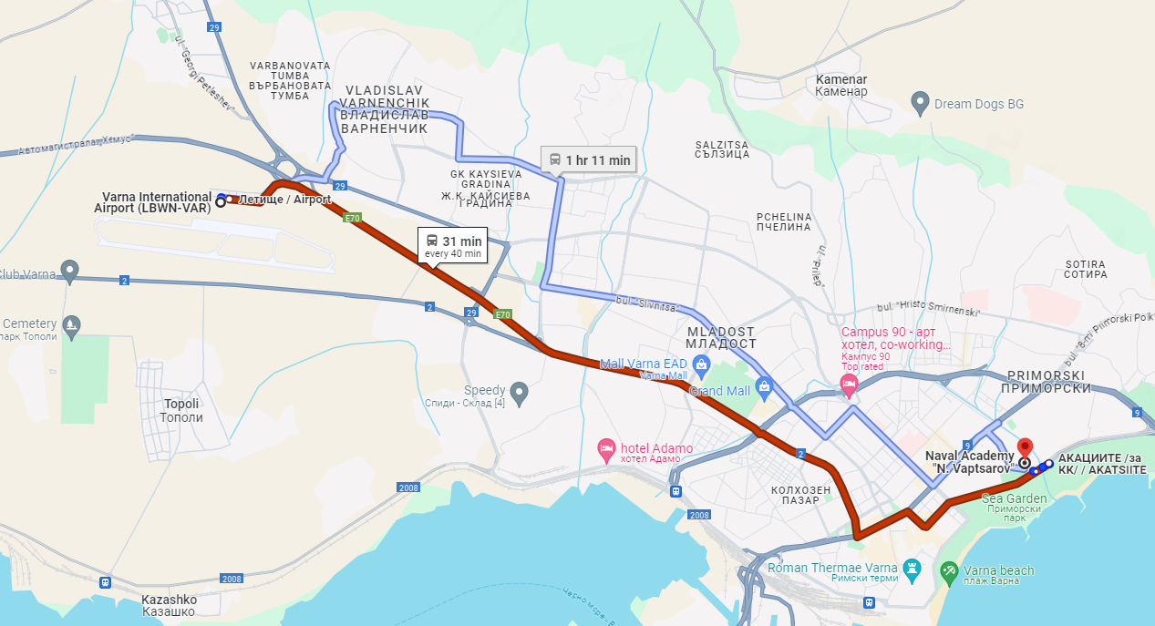](https://www.google.com/maps/place/%D0%92%D0%B8%D1%81%D1%88%D0%B5+%D0%B2%D0%BE%D0%B5%D0%BD%D0%BD%D0%BE%D0%BC%D0%BE%D1%80%D1%81%D0%BA%D0%BE+%D1%83%D1%87%D0%B8%D0%BB%D0%B8%D1%89%D0%B5+%E2%80%9E%D0%9D.+%D0%99.+%D0%92%D0%B0%D0%BF%D1%86%D0%B0%D1%80%D0%BE%D0%B2%E2%80%9C/@43.2119487,27.9281177,17z/data=!3m1!4b1!4m6!3m5!1s0x40a4541aac9da1ab:0x780f7a1dbc94222a!8m2!3d43.2119449!4d27.9329886!16zL20vMGNzNm16?entry=ttu)

**Public Transport Directions**

There is no transportation to and from the meeting site and the hotel is within walking distance (maximum 10-15 minutes from Naval Academy)

The most detailed information about buses, lines, stations, and routes in Varna is available at: <https://www.varnatraffic.com/en-En>. You can download the application #VarnaTraffic for Android or if you prefer you may also use #Moovit App with location area set to Varna, Bulgaria.

**How & where to buy tickets?**

You can purchase tickets from a bus ticket machine located at the bus stops as well as in all public transport vehicles. You can also purchase tickets online with #TicketVarna mobile app.

Information about ticket fares is available on <http://tasrud-varna.com/?page_id=189>

|  |  |  |  |
| --- | --- | --- | --- |
| At the BUS station or in the bus | | Online Via TicketVarna mobile app | |
| Tickets | Fare | Tickets | Fare |
| 60 minutes | 2,00 BGN | 60 minutes | 1,00 BGN |
| 90 minutes | 2,50 BGN | 90 minutes | 1,50 BGN |
| Day ride | 4,00 BGN | n/a | n/a |

***Tickets*** - tickets purchased at the bus stop or on the bus are valid from the moment of purchase. Tickets must be validated entering the bus as well as when transfer between buses. Tickets purchased in the bus must be validated when transfer between buses only.

Prepaid bus travel cards - you can purchase a prepaid bus travel card. When you top up your card with 10 BGN you earn 1 BGN extra. Bus travel card must be validated entering the bus. At the moment of validation, you choose between 60- or 90-minutes ride.

Most important tourist lines from the public transport in Varna:

***Bus line № 409*** connects the airport with the shopping centers, bus station, city center/cathedral, dolphinarium and the nearby summer resorts "St. Constantine and Helena", "Chayka" and "Golden sands" (summer season only). A bus ride from the airport to the central part of Varna takes about 20 minutes and to the resort "Golden Sands" - about 50 minutes.

***Bus line № 9*** connects the central railway station with the city center/Cathedral - Dolphinarium and the resorts "St. Constantine and Helena" and "Golden sands".

***Bus line № 31А*** connects the central railway station with the city center/Cathedral - and the resort "St. Constantine and Helena".

***Trolleybus № 82*** (direction „Vladislav Varnenchik” park-museum) connects the central railway station with the city center/post office and the „Vladislav Varnenchik” park-museum.

In Varna there are two public transport service providers. The call center staff are available to answer all your questions at:

Gradski Transport EAD - +359 (0) 700 10933; e-mail: gtvarna@abv.bg web: www.gtvarna.com

Chensfild - +359 87 830 0680; e-mail: chensfild@gmail.com; web: www.chensfild.bg

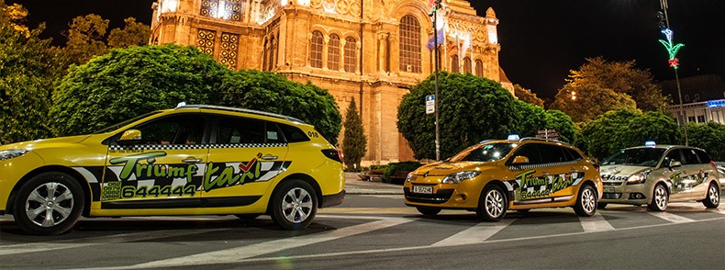

**Taxi Service in Varna**

* The largest taxi company in Varna is ***Triumf taxi.*** The reputation of the company is built on the correctness of the services.   
  The tariffs per kilometer are:   
  - daily (06AM-22PM) 1.30 lev (BGN) = 0.66 EUR/km with initial fee of 2.60 lev (BGN)    
  - nightly (22PM-06AM) 1.50 lev (BGN) = 0.76 EUR/km with initial fee of 3.00 lev (BGN)   
  Telephone for orders: +359 52 644444; +359 879 644444; +359 882644444   
  <https://triumftaxi.com/en/tariffs>
* ***Omega taxi*** – The second taxi company with a good reputation on correctness of the services.   
  The tariffs per kilometer are:   
  - daily (06AM-22PM) 1.30 lev (BGN) = 0.66 EUR/km with initial fee of 2.60 lev (BGN)    
  - nightly (22PM-06AM) 1.50 lev (BGN) = 0.76 EUR/km with initial fee of 3.00 lev (BGN)   
  Telephone for orders: +359 52 388888; +359 878 388888; +359 888 388888; +359 898 388888   
  <http://omegataxivarna.com/>
* ***Hippo taxi*** – The third taxi company with a good reputation on correctness of the services.   
  The tariffs per kilometer are:   
  - daily (06AM-22PM) 1.30 lev (BGN) = 0.66 EUR/km with initial fee of 2.60 lev (BGN)    
  - nightly (22PM-06AM) 1.50 lev (BGN) = 0.77 EUR/km with initial fee of 3.00 lev (BGN)   
  Telephone for orders: +359 52 344444; +359 876 344444; +359 883 344444; +359 899 344444   
  <https://hippotaxi.bg/>

**Arrival in Bulgaria**

* ***Arriving at Varna Airport***
* Varna Airport (VAR) offers international flights to and from the Bulgarian Sea capital - Varna. Almost 70 different airlines fly to Varna and the airport provides convenient direct links to 16 cities [all year round](https://varna-airport.bg/flights/destinations/winter%22%20/t%20%22_blank) and more than 120 cities [seasonal](https://varna-airport.bg/flights/destinations/seasonal%22%20/t%20%22_blank). Every year more than 2 million passengers pass through this airport.
* Varna Airport is situated just 7 kilometres from the city center. Directly from the terminal you can rent a car or order a taxi to your final destination in or around the city.
* By public transport:
* Bus 409 connects Varna International Airport with the Central Bus Station (15 min.), city center - Cathedral (20 min.), Sts. Contantine and Helena Resort (30 min.), Chayka (35 min.) and Golden Sands Resort (50 min.). You should not have to wait longer than 15 minutes for a bus, which departs from the Bus Stop ("[Letishte](https://varnatraffic.com/Station/Index/50" \t "_blank)") in front of Terminal 2 Arrivals.
* A ticket can be purchased from a ticket machine located on the bus stops as well as in all public transport vehicles.
* By taxi:
* A 24-hour taxi service is available at Varna Airport. You may find the yellow taxi cabs of Triumf Taxi in front of Terminal 2.
* You can book your transfer from Varna Airport online at www.triumftaxi.com or call:
* +359 52 644444; +359 882 644 444.
* The Taxi company representatives await in front of Terminal 2. You may also find them inside the terminal behind the counter of the taxi service provider. You will be accommodated with the most suitable car for you and your luggage which will take you safely and comfortably to your preferred destination.
* Contacts:                 <https://varna-airport.bg/en>                      Flight Information: +359 52 573 323
* ***Arriving at Sofia***
* The best way to get from Sofia Airport (SOF) to Varna-is by air (recommended) or rental car.
* Sofia (SOF) to Varna (VAR) flights:
* The flight time between Sofia (SOF) and Varna (VAR) is around 50 min and covers a distance of around 365 km. Services are operated by Bulgaria Air. Typically 14 flights run weekly, although weekend and holiday schedules can vary so check in advance.
* There is no direct bus from Sofia Airport (SOF) to Varna. However, there are services departing from Sofia Airport Departure Terminal 1 and arriving at Varna via Stara Zagora. The journey, including transfers, takes approximately 12h 20min.
* Contacts:                https://www.sofia-airport.bg/en   Flight Information +359 2 937 211, +359 2 937 2212, +359 2 937 2213

**Contact persons at Nikola Vaptsarov Naval Academy**

|  |  |  |
| --- | --- | --- |
| Georgi Markov | g.markov@nvna.eu | - |
| Desislava Zografova | [erasmus@nvna.eu](mailto:erasmus@nvna.eu) | +359 887 670 330 |
| Teodora Gandeva | [erasmus@nvna.eu](mailto:erasmus@nvna.eu) | +359 894 879 397 |