 | PROJECT LOGO |  | 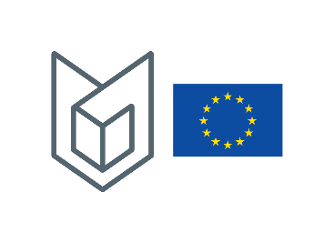
TITLE OF THE PROJECT

Project's Partners
Contact person:
Project's website:
Contract number:
Budget:
Duration:
Objectives:
Main results (intellectual outputs):
Target groups:
Elaborated common modules: | Common module title | ECTS

